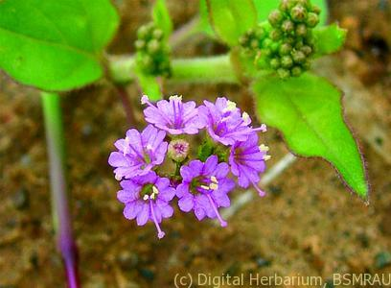

Nature Rejuvenation is at once science and art, and putting the same into practice depends not just upon the knowledge, but also upon the empathy and sensitivity of the practitioner. For restoring or improving any vacant land, agricultural field or a patch of degraded jungle, the ecologists have to assess the native and local level natural attributes at and around the given site as the first step. A good understanding of the guidelines and framework suggested by Nature is a basic prerequisite in order to succeed in such an endeavour. Every place has its own needs, which can be studied and recognised by experts and measures can be undertaken to increase the pace at which Nature can do the restoration work.

Our natural resources are dwindling at an alarming rate, and it is the duty of us all to do our own bit to restore the natural balance. Many people residing in cities have a piece of land adjacent to the city or in some nearby village. Most often, due to lack of proper information and guidance, such people do not know how they can use these lands for restoring Nature. “Punarnava” can provide following services in this respect…

* Scientific documentation of land
* Land Class Assessment
* Master plan preparation with an ecological perspective
* Eco-sensitive construction and development consultancy
* Plantation Guidelines
* Ecological management